CREATING A REST API USING BNA FROM INSTANCE

For creating a rest API from the bna, we have to first install the pre-requisites needed for the hyperledger composer.

1. **Installing Pre-requisites:**

Following points should be noted while installing pre-requisites for Ubuntu instance.

Login as a normal user, rather than root.

* Do not su to root.
* When installing prerequisites, use curl, then unzip using sudo.
* Run prereqs-ubuntu.sh as a normal user. It may prompt for root password as some of it's actions are required to be run as root.

Commands to be used for installing pre-requisites:

curl -O https://hyperledger.github.io/composer/latest/prereqs-ubuntu.sh

chmod u+x prereqs-ubuntu.sh

./prereqs-ubuntu.sh

Next we have to install the development environment.

1. **Installing Components**
   1. Install the CLI tools:

We have to install 4 CLI tools

1. Composer-cli
2. Generator-hyperledger-composer
3. Composer-rest-server
4. Yeoman

Composer-cli consists of all the essential operations. The last 3 components are not core-parts of the network, but they need to be installed if you are developing applications that interact with business network.

Commands to be followed to install the CLI tools

1. Essential CLI tools:

npm install -g composer-cli@0.20

1. Utility for running a REST server on your machine to expose your business networks as REST APIs:

npm install -g composer-rest-server@0.20

1. Useful utility for generating application assets:

npm install -g generator-hyperledger-composer@0.20

1. Yeoman is a tool for generating applications, which utilises generator-hyperledger-composer

npm install -g yo

* 1. Install Hyperledger Fabric:

1. This gives a local hyperledger fabric runtime to deploy your business networks to.

In a directory of your choice (we assume ~/fabric-dev-servers), get the .tar.gz file that contains tools to install hyperledger fabric.

mkdir ~/fabric-dev-servers && cd ~/fabric-dev-servers

curl -o https://raw.githubusercontent.com/hyperledger/composer-tools/master/packages/fabric-dev-servers/fabric-dev-servers.tar.gz

tar -xvf fabric-dev-servers.tar.gz

1. Use the scripts just downloaded and extracted to download a local hyperledger fabric v1.2 runtime:

cd ~/fabric-dev-servers

export FABRIC_VERSION=hlfv12

./downloadFabric.sh

* 1. Controlling dev environment

There are a set of script files(.sh) inside fabric-dev-servers directory. We can control the hyperledger fabric environment using these set of scripts.

The first time when starting a new runtime, we need to run the start script and generate a peerAdmin card.

cd ~/fabric-dev-servers

export FABRIC_VERSION=hlfv12

./startFabric.sh

./createPeerAdminCard.sh

We can stop the script by running ./stopFabric.sh.

At the end of the development session, we need to run ~/fabric-dev-servers/stopFabric.sh and then ~/fabric-dev-servers/teardownFabric.sh.

If we run the teardown script, the next time when you start the environment, new peerAdmin cad should be created.

1. **Deploying the Business Network**

Now we have to create the bna into one directory. We can download the bna from github using the curl command.

Example command:

Curl –o pharma-network.bna <https://raw.githubusercontent.com/RinuT/chaincode/master/pharma-network.bna>

We have to make sure that we are downloading the raw file of bna from github.com. Otherwise it will generate an error while installing.

After creating the .bna file, the business network can be deployed to instance of the hyperledger fabric

Normally, information from the Fabric administrator is required to create a **PeerAdmin** identity, with privileges to install chaincode to the peer as well as start chaincode on the **composerchannel** channel. However, as part of the development environment installation, a **PeerAdmin** identity has been created already.

After the business network has been installed, the network can be started. For best practice, a new identity should be created to administer the business network after deployment. This identity is referred to as a network admin.

Deploying a business network to the Hyperledger Fabric requires the Hyperledger Composer business network to be installed on the peer, then the business network can be started, and a new participant, identity, and associated card must be created to be the network administrator. Finally, the network administrator business network card must be imported for use, and the network can then be pinged to check it is responding.

Navigate to the business network directory and run the following

1. To install the business network run the following command

composer network install --card PeerAdmin@hlfv1 --archiveFile tutorial-network@0.0.1.bna

The composer network install command requires a PeerAdmin business network card (in this case one has been created and imported in advance), and the file path of the .bna which defines the business network.

1. To start the business network, run the following command

composer network start --networkName tutorial-network --networkVersion 0.0.1 --networkAdmin admin --networkAdminEnrollSecret adminpw --card PeerAdmin@hlfv1 --file networkadmin.card

The composer network start command requires a business network card, as well as the name of the admin identity for the business network, the name and version of the business network and the name of the file to be created ready to import as a business network card.

1. Import the network admin card

composer card import --file networkadmin.card

1. To check that the business network has been deployed successfully, run the following command to ping the network

composer network ping --card admin@tutorial-network

The composer network ping command requires a business network card to identify the network to ping.

Generate REST API

To generate REST API run the following command:

composer-rest-server

It will ask for the card name. Enter the card name. Here it is admin@tutorial-network

Select never use namespaces when asked whether to use namespaces in the generated API.

For the rest of questions press enter for default values

The generated API will be connected to the deployed blockchain and business network.

The instance will look like following:

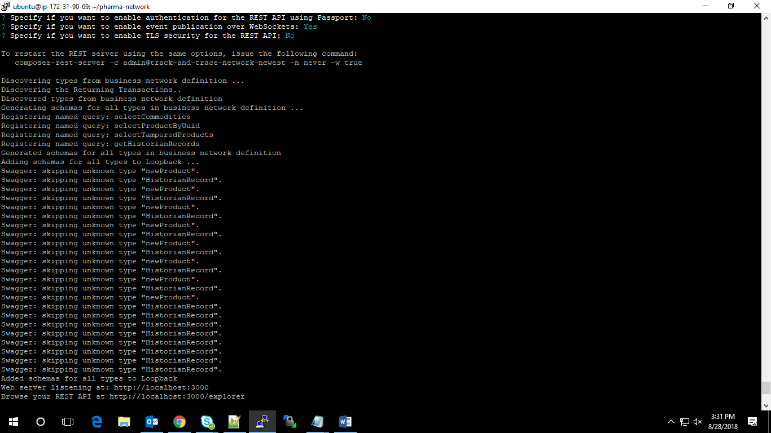

<https://hyperledger.github.io/composer/latest/tutorials/developer-tutorial>

Note

Deleting docker

1) docker rm -f $(docker ps -aq)

2) docker rmi -f $(docker images -q)

Checking card list - composer card list

Deleting composer card – composer card delete --card admin@tutorial-network